**Face Recognition Based Attendance System**

ABSTRACT

Automatic face recognition (AFR) technologies have made many improvements in the changing world. Smart Attendance using Real-Time Face Recognition is a real-world solution which comes with day to day activities of handling student attendance system. Face recognition-based attendance system is a process of recognizing the students face for taking attendance by using face biometrics based on high definition monitor video and other information technology. In my face recognition project, a computer system will be able to find and recognize human faces fast and precisely in images or videos that are being captured through a surveillance camera. Numerous algorithms and techniques have been developed for improving the performance of face recognition but the concept to be implemented here is Deep Learning. It helps in conversion of the frames of the video into images so that the face of the student can be easily recognized for their attendance so that the attendance database can be easily reflected automatically

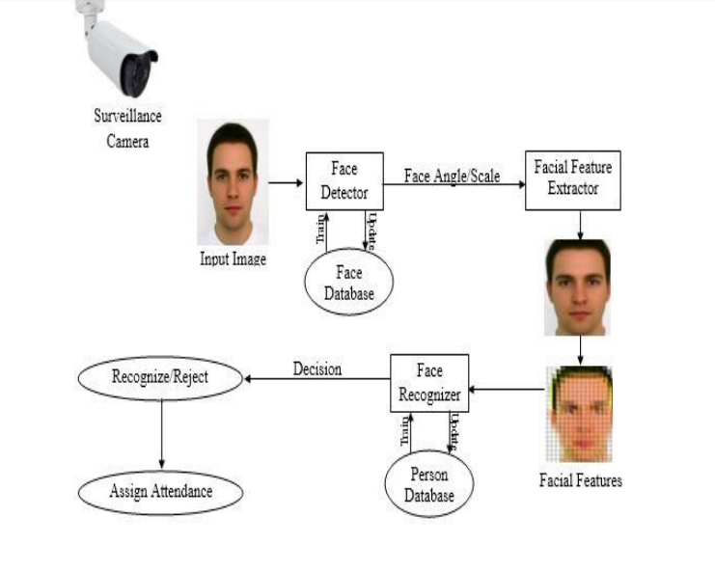

With this project we can easily take the attendance of students easily by just passing in front of a camera, by this method we can reduce the human effort and archive maximum efficiency, in this project we are using python script for face recognition and marking of attendance.